**DIAGRAMAS DE CLASES**

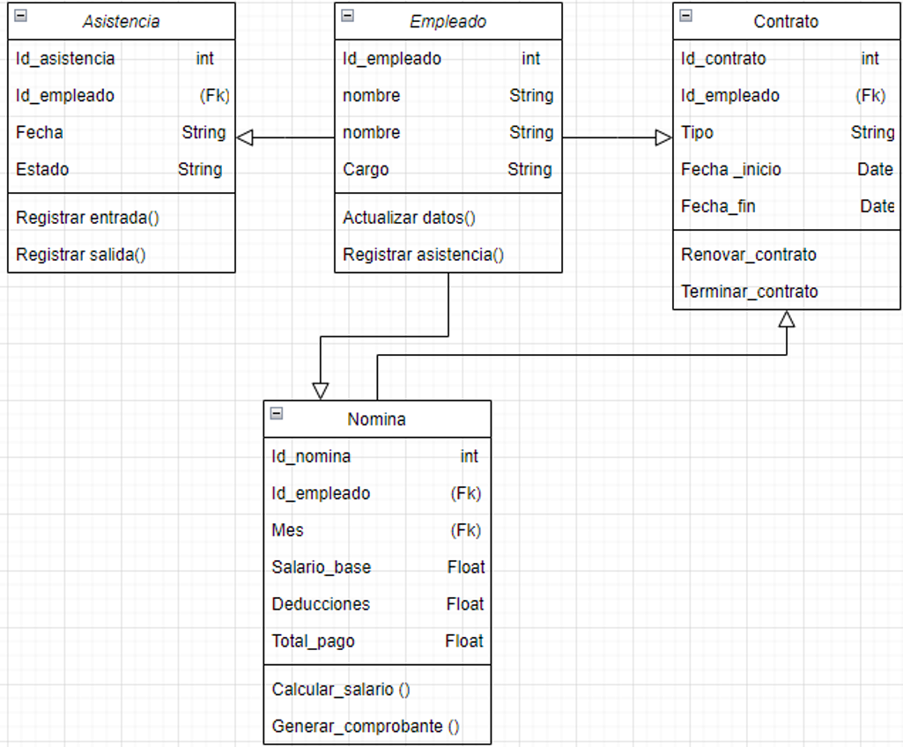

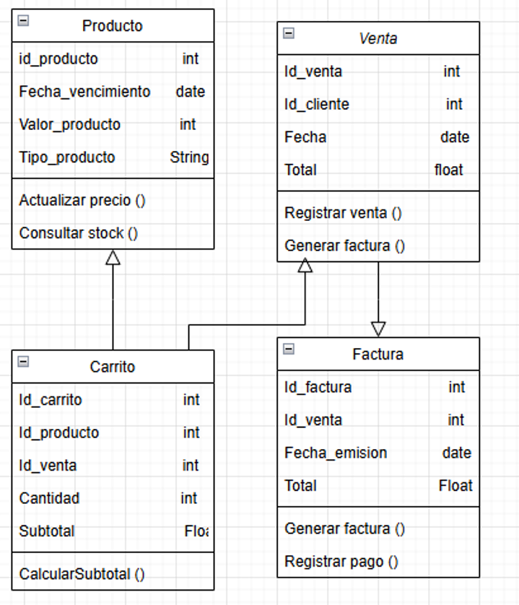

**DIAGRAMAS DE COMPONENTES**

